mrc vs spatial multiplexing

COMPARE BER AND GOODPUT

# BER

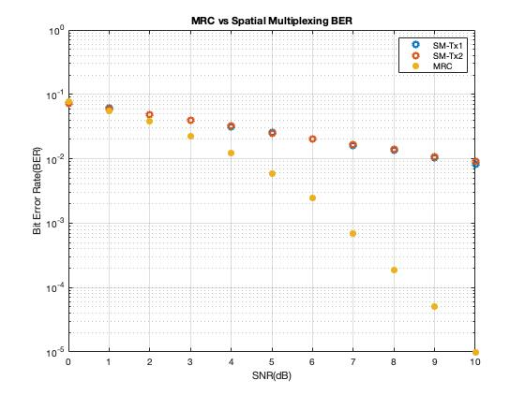

As we can see from the above plot, MRC method has better BER (Bit-Error-Rate) than the Spatial Multiplexing as the SNR increases. That was expected, since MRC method sends the same symbol to both of the antennas of the receiver. This has better chances to receive and decode the symbol correctly rather than the spatial multiplexing, which sends at the same time to different symbols.

# Goodput

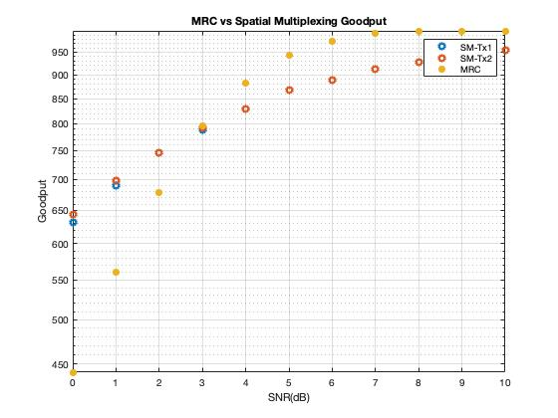

As we can see from the above plot, the point where SNR = 3 is a critical point. For SNR lower than 3 the MRC method has lower goodput than Spatial Multiplexing and for SNR greater than or equal to 3 starts getting greater than Spatial Multiplexing. If we observe carefully the BER plot we can see from SNR = 3 and then, MRC’s BER starts to have significant difference with Spatial Multiplexing’s BER. So, for me is reasonable the result.

As result, we can see that for low SNR values is better to choose Spatial Multiplexing method, but for greater values of SNR it is better to choose MRC .